Report of Digital Storytelling

Sare Sengul - Dilek Ersoz
20505256 - 20502346

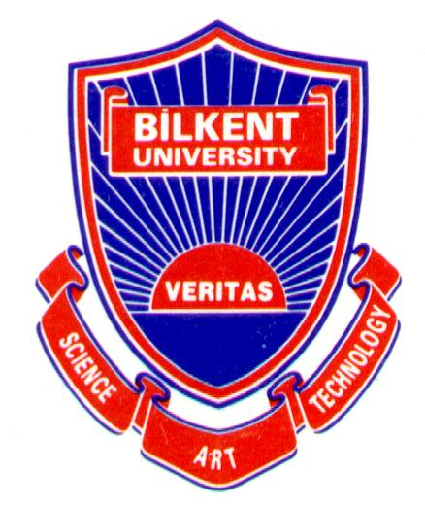

Graduate School of Education
Bilkent University
TE 504-1Educational Technology and Materials Development
Fall 2010

Content
Introduction…………….………………………………………………………………………………………………….2
1-Main topic of the project……………………………………………………………………………………….….3
2-Major objectives of the project…………………………………………………………………………….…..4
3-Selection of the topic………………………………………………………………………………………….…….5
4-Description of the images………………………………………………………………………………………….6
5-Usage of the project………………………………………………………………………………………………….7
6-Process of the project……………………………………………………………………………………………….8
7-Major challenges of the project………………………………………………………………………………..9
8-The most important things…………………………………………………….………………………………..10
9-Other information……………………………………………………………………………………………………11
10-Conclusion……………………………………………………………………………………………………………..12

Introduction
In this report, we are going to explain a project which is digital storytelling. Firstly, we will talk about the main topic, major objectives of the project. Later on, we will continue to write how we selected the topic and we describe the images of the project. Then, we will focus on how we can use this project and we will list the process of the project. At the end, we will analyze the major challenges and the most significant things in the project. Lastly, we will add other information to conclude.

Main Topic of the Project
The main topic of the project is Christmas. In this digital storytelling, there is a story about a fir tree. This little fir tree feels so upset, because the other tall trees around it were cut down and were sent for Christmas. At the end, the woodcutters came and cut down this little fir tree and he was bought by a family in the market. He became a Christmas tree and he felt so happy with his ornaments. After digital storytelling, there is a song called “Santa Claus is Coming to Town” by The Countdown Kids. Additionally, there are written scripts both for the story and the song.
For the main topic, we put a story to show the significance of the Christmas. We add a song related to Santa Claus who is directly the symbol of Christmas. We try to choose a real life topic and we try to give enough information about the characteristics of Christmas.

Major Objectives of the Project
For teachers;
- Enhance current lesson plans with the use of a digital story within a unit.
- Apply to the different learning styles of the students by using Digital Storytelling as a presentation media.
- Generate interest, attention and motivation for the digital generation kids in the classroom.
- Create an enjoyable environment to make the students participate more.
- Post students’ works on the Internet site for viewing, making comments and criticisms by other students.
- Observe students’ development on vocabulary and specific grammar rules by preparing related activities.
For students;
- Learn to use computer and Internet effectively.
- Search deeply on Internet
- Analyze and synthesize a wide range of content.
- Develop learning abilities such as visual, auditory and kinesthetic, so that each student has chance to understand.
- See the difference between traditional and digital story telling.
- Increase computer skills.
- Study in technology integrated education.
- Enjoy while learning.

Selection of the topic
We chose an authentic topic “Christmas”, because New Year is coming and we thought that the students can eagerly learn and participate in the activity. With the help of Digital Storytelling, we can teach a story “The Fir Tree”, we can teach new words and a song related to the topic. We think that mostly primary school students would be interested in viewing this project, because while they are listening and watching, they learn story and song at the same time.
We thought that Christmas can be an interesting topic and we know that everybody in the world knows something about Christmas. Therefore, this topic can take everybody’s attention and people can watch it.

Description of the Images
- In the Digital Storytelling, there are not so many different images.
- At the beginning of the video, there is Santa Claus and Christmas tree to make the audience guess what the video is about.
- For the story part, there are same fir tree images and small images related the topic such as woodcutter, Christmas tree, children, snow…
- For the song part, there are Santa Clauses, snowman, presents for the children and Santa Claus’s touring car with deer.

We usually use similar images and we modified with image editing software. In the story, the fir tree is the main character of our story, so we should use fir tree in each slide. In the song, Santa Claus is coming to town; therefore we chose different Santa Claus images to relate to the song.

Usage of the Project
This project might be used in for both formal and informal educational setting. In the school (formal), this project can be used for literature classes. There is a story about Christmas; therefore teachers can use this project to teach Christmas song. Moreover, teachers can show this video for listening and reading activities, since students can read while they are listening. Digital storytelling can enable students to learn story by listening and reading, so that this class will be technology integrated education system. In addition to, teachers can use this project for vocabulary teaching about Christmas and can use song for fluent speaking and pronunciation.
In terms of informal usage, this project can be used for enjoyment, description of Christmas, listening to a entertaining story and listening to a song. People can show this video to the little children to show how Christmas is celebrated in their houses. Also, people can entertain themselves by using ınternet and other students can use this project as a source.

Process of the Project
Software Programs
- Windows Movie Maker- to create a video.
- Image Editing Software- to edit the images.
- Voice Recorder- to record our voice.
- Internet- to search information.
Content of the Project
- Brainstorm an idea for our story.
- Consider audience and purpose.
- Find a suitable authentic topic.
- Use storyboard to determine the sequence of the story.
- Search for the story.
- Develop a narrative script.
- Collect and create images for the story and song.
- Identify music for soundtrack.
- Record our voice.
- Begin to create.
Changes of the ideas when creating the video
- Nothing has changed.

Major Challenges of the Project
In fact, we faced just a problem during the preparation of the project. After we put our song into the video, we could not put our voice record at the beginning of the video. Later, we managed to put our record, but it played after song has finished. We could not arrange exact time for each slide, but we wanted voice record to play first, so that this was a big challenge for us.

The most important things
We firstly learn how to make a video, how to edit images, how to add written scripts and how to arrange slide transitions. Before this project, we did not have any idea about how to create a video, so the most important thing is to learn to do it. We can tell a story by this video and we can arrange time for each slide. We can now use Digital Storytelling for our own teaching in the future. We can use this project for story teaching, song teaching and activity preparation.

Other Things
As student-teachers, we really enjoyed while preparing this project and we find Digital Storytelling very useful for listening, reading and speaking activities, because images make the lesson more understandable. It takes time, but we tried to create well-prepared and enjoyable story for the kids.
Benefits of Digital Storytelling
- Encourages collaborative learning
- Develops problem solving
- Allows students to learn and present in their own learning style
- Motivates students since it is related their personal experience
- Practical and meaningful way to learn new technology
- Increases digital literacy

Conclusion
To conclude, we discussed the preparation and development part of our project in this report. We explained topic, aims, formal and informal usages, difficulties and stages of process while we were working on this project. We wrote brief explanation for each part and reflect what we experienced during working time.

